**Faculty of Technology Management Information System**

**System Requirements Specifications**

Table of Contents

Introduction 3

Overall Description 4

System features and Requirements 5

# Introduction

* **Definition**

We use this System Requirement Specifications report to determine the functions and the purpose of the Faculty of Technology management information system Called TECMIS.

* **Intended use.**

The intended use of a Faculty of Technology Management Information System is to streamline and enhance administrative processes, improve communication, and provide valuable insights for better decision-making.

* Information management
* Registrations
* Attendance taking
* Grading
* Course management
* Reporting and analysis
* Security and access control
* **Acronymous**
* TECMIS – Technology Management Information System
* SGPA – Semester Grade Point Average
* CGPA – Cumulative Grade Point Average
* CA – Continuous Assessment
* MIS – Management Information System
* LMS – Learning Management System

# Overall Description

* **User Needs**

Faculty of Technology MIS is a system that allows administrators, Dean, Students, Lectures and Technical officers to do lots of tasks like attendance calculating, Grade calculating etc. Also, it helps the above users to manage their information and data.

* **Context Diagram**

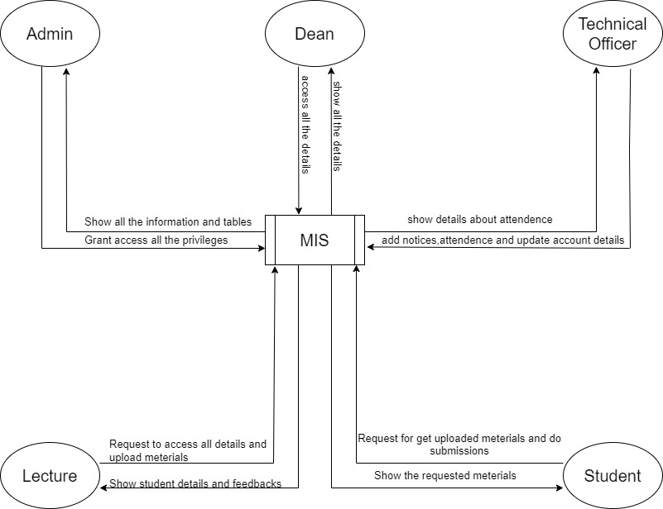

# System features and Requirements

* Functional Requirements
* **Admin**
* Add a new admin user account.
* View admin details
* Update admin details
* Delete admin user account.
* **Dean**
* Add a new dean user account.
* View dean’s details
* Update dean's details
* Delete dean's user account.
* **Lecture**
* Update profile information
* Add and update course materials.
* Get Student details.
* Get student’s assignment submissions.
* Add course grades and exam marks.
* Get attendance of students.
* Get notices.
* **Student**
* Update contact and account details.
* Get course materials and details.
* Get attendance.
* Get timetables.
* Get Grades and GPA.
* Get notices and notifications.
* **Technical Officer**
* Update profile information.
* Add and update medical submissions of students.
* Add and update attendance details of students.
* Get notices.
* **Non-functional Requirements**
* **Performance and scalability**

Faculty of technology MIS should be very fast and responsive to users. Otherwise, it will be a less effective system. For this effectiveness of a system depends on several factors.

* Response time
* Load time
* Data storage
* Concurrent users
* **Portability and compatibility**

MIS should be portability and compatibility. Which means it will be platform independent system. When it comes to portability users can run on any browser without affecting any disruptions.

* **Security**

In this MIS there are several users with several granted privileges. In this situation we need to enhance security and access control among each other. As we get an example student cannot be updated lecture profile details. Therefore, relevant users can access to the relevant sections.

* **Usability**

Users can use this system easily and determine functionalities easily.

* Learnability (Main actions will be fast once user see the interface)
* Efficiency (MIS will be reach users goals in least time)
* Memorability
* Satisfaction
* User friendly interface

Group NO-07 members: -

* TG/2021/1062 – Samindika
* TG/2021/1040 – Janith
* TG/2021/1011- Asith
* TG/2021/1016 - Supun